Exp 3

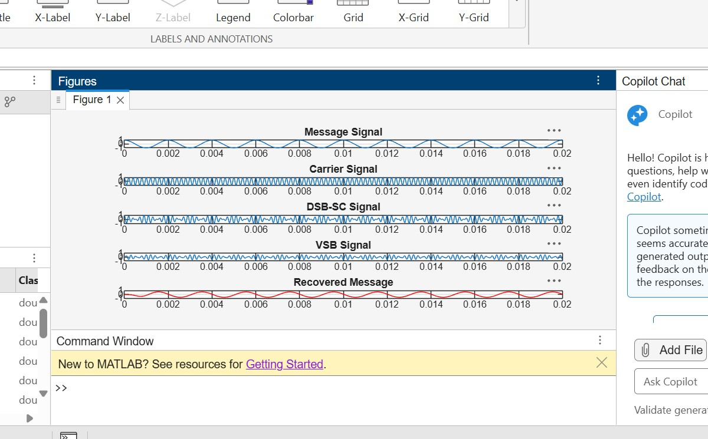

clc;

clear; close all;
% Parameters
fs = 100000; % Sampling Frequency t = 0:1/fs:0.02; % Time Vector
fm = 500; % Message Frequency fc = 5000; % Carrier Frequency
% Message Signal m = cos(2*pi*fm*t);
% Carrier Signal
c = cos(2*pi*fc*t);
% DSB-SC Modulation dsb = m .* c;
% VSB Filter (Low-pass + High-pass Approximation)

[b,a] = butter(4, fc/(fs/2)); vsb = filter(b,a,dsb);
% Coherent Demodulation
demod = vsb .* (2*cos(2*pi*fc*t));
% Recover Message
[b1,a1] = butter(4, 1000/(fs/2)); rec = filter(b1,a1,demod);
% Display Results figure; subplot(5,1,1) plot(t,m)
title('Message Signal') grid on
subplot(5,1,2) plot(t,c) title('Carrier Signal') grid on subplot(5,1,3) plot(t,dsb)
title('DSB-SC Signal') grid on
subplot(5,1,4) plot(t,vsb) title('VSB Signal') grid on subplot(5,1,5) plot(t,rec,'r')
title('Recovered Message') grid on

exp 4
clc; clear; close all;
% Parameters fs = 100000;
t = 0:1/fs:0.02;
fm = 500; % Message frequency fc = 10000; % Carrier frequency
fLO = 14550; % Local Oscillator (IF = 4550 Hz)
% Message Signal

m = cos(2*pi*fm*t);
% Carrier Signal
c = cos(2*pi*fc*t);
% AM Signal
am = (1 + m).*cos(2*pi*fc*t);
% Local Oscillator
LO = cos(2*pi*fLO*t);
% Frequency Mixing mixed = am .* LO;
% IF Filter
[b,a] = butter(4,5000/(fs/2)); IF = filter(b,a,mixed);
% Envelope Detection env = abs(hilbert(IF));
% Display figure; subplot(4,1,1) plot(t,m)
title('Message Signal')

grid on figure; subplot(5,1,2) plot(t,c)
title('Carrier Signal') grid on subplot(5,1,3) plot(t,am)
title('AM Signal') grid on subplot(5,1,4) plot(t,IF)
title('Intermediate Frequency (IF) Signal') grid on
subplot(5,1,5) plot(t,env) title('Recovered Signal') grid on

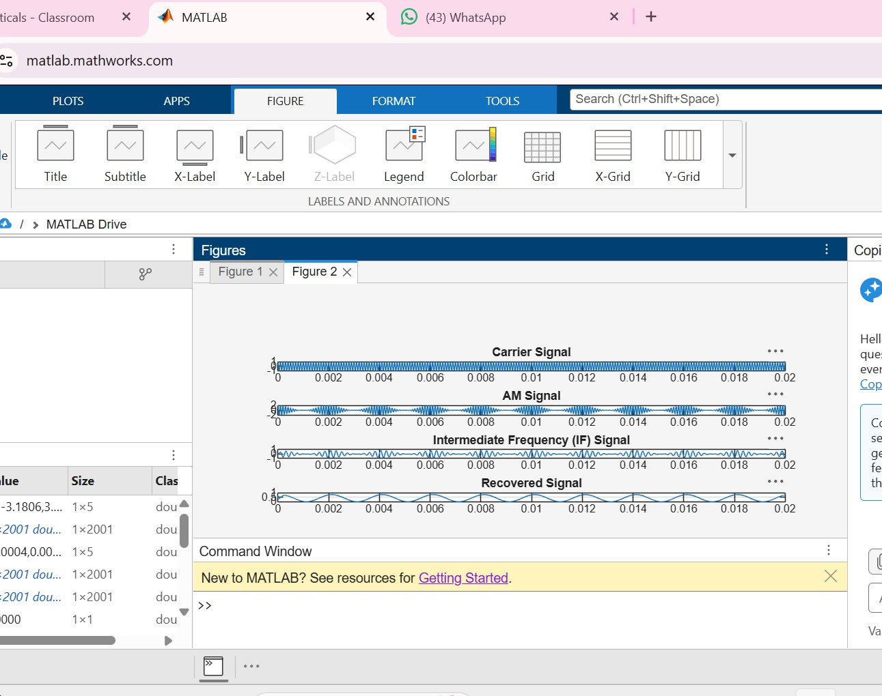

Exp 6

clc; clear; close all; Am=1; Ac=1;
fm=5; fc=50; beta=5; kp=5; fs=1000;
t=0:1/fs:1;
m = Am*cos(2*pi*fm*t); % Message signal

c = Ac*cos(2*pi*fc*t); % Carrier signal
fm_sig = Ac*cos(2*pi*fc*t + beta*sin(2*pi*fm*t)); % FM pm_sig = Ac*cos(2*pi*fc*t + kp*m); % PM
Df = beta*fm; % Frequency deviation fprintf('Frequency Deviation = %d Hz\n',Df); fprintf('FM Modulation Index = %d\n',beta); subplot(4,1,1), plot(t,m), title('Message Signal') subplot(4,1,2), plot(t,c), title('Carrier Signal') subplot(4,1,3), plot(t,fm_sig), title('FM Signal') subplot(4,1,4), plot(t,pm_sig), title('PM Signal')

